Problem Sheet 2a - Probability Mass Distributions

## Question 1

1. The probability mass function of a discrete random variable X is given in the follow- ing table:

Q1: Probability Mass Function.

| x | Pr |
| --- | --- |
| 0 | 0.1 |
| 1 | 0.2 |
| 2 | 0.4 |
| 3 | 0.2 |
| 4 | 0.1 |

Find the E[X] and Var [X].

### **ANSWER**

Q1: Expected Value Calculation

| i | x | Pr | xPr |
| --- | --- | --- | --- |
| 0 | 0 | 0.1 | 0.0 |
| 1 | 1 | 0.2 | 0.2 |
| 2 | 2 | 0.4 | 0.8 |
| 3 | 3 | 0.2 | 0.6 |
| 4 | 4 | 0.1 | 0.4 |

The expected value E[X] is 2.

Q1: Variance Calculation

| i | x | Pr | xPr | var_x |
| --- | --- | --- | --- | --- |
| 0 | 0 | 0.1 | 0.0 | 0.4 |
| 1 | 1 | 0.2 | 0.2 | 0.2 |
| 2 | 2 | 0.4 | 0.8 | 0.0 |
| 3 | 3 | 0.2 | 0.6 | 0.2 |
| 4 | 4 | 0.1 | 0.4 | 0.4 |

The Variance value VAR[X] is 1.2.

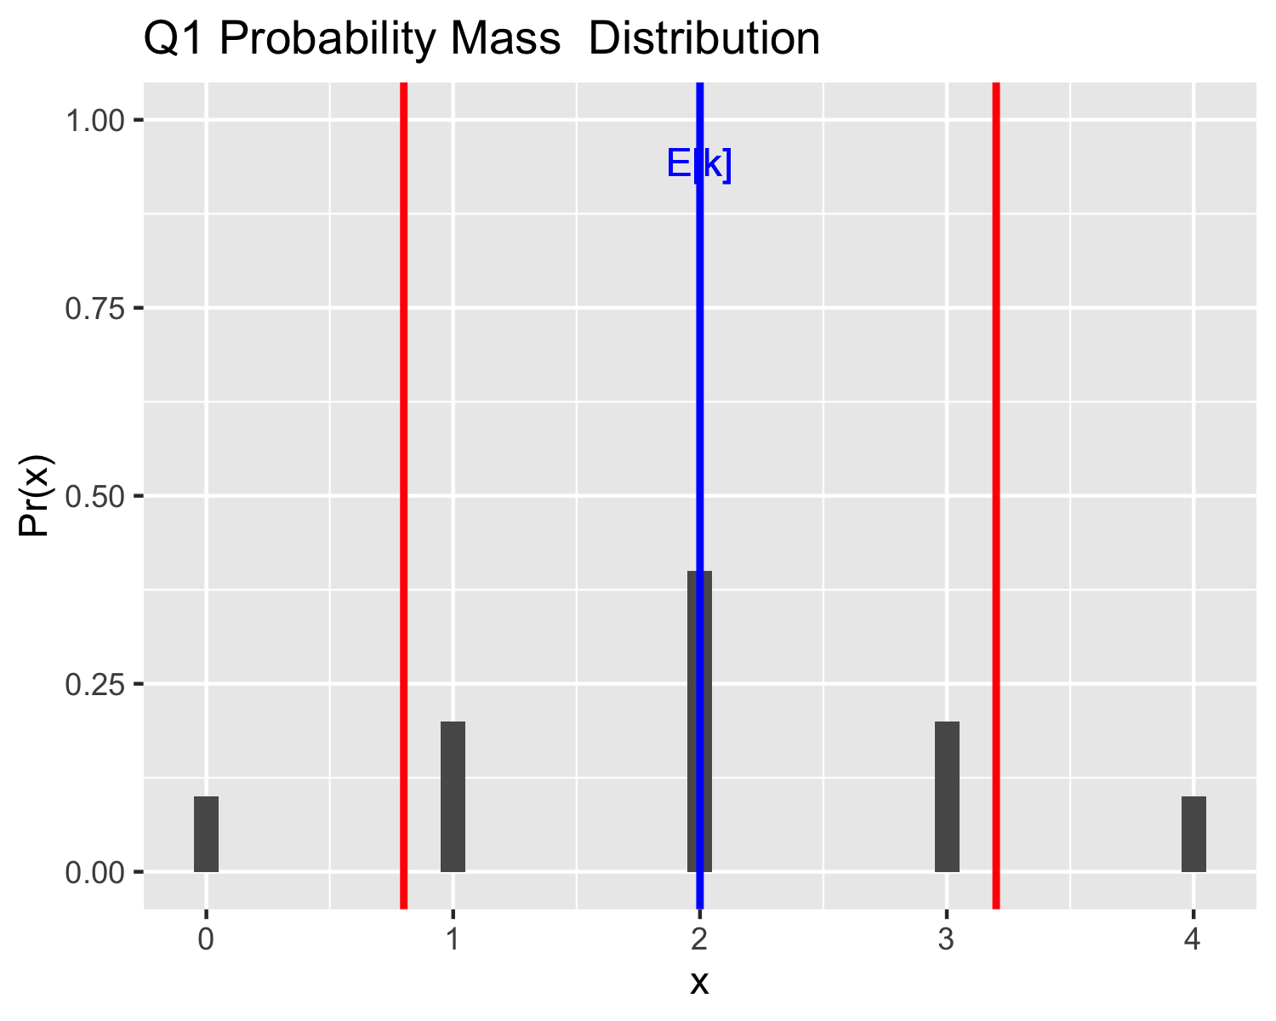

## Question 2

The probability mass function of a discrete random variable X is given in the following table:

Show that p3 = 0.2

### **ANSWER**

re-arranging

Q2: Probability Mass Function.

| x | Pr |
| --- | --- |
| -2 | 0.1 |
| -1 | 0.3 |
| 0 | 0.3 |
| 1 | 0.2 |
| 2 | 0.1 |

and calculate the E [X ].

### **ANSWER**

Q2: Expected Value Calculation

| i | x | Pr | xPr |
| --- | --- | --- | --- |
| 0 | -2 | 0.1 | -0.2 |
| 1 | -1 | 0.3 | -0.3 |
| 2 | 0 | 0.3 | 0.0 |
| 3 | 1 | 0.2 | 0.2 |
| 4 | 2 | 0.1 | 0.2 |

The expected value E[X] is -0.1.

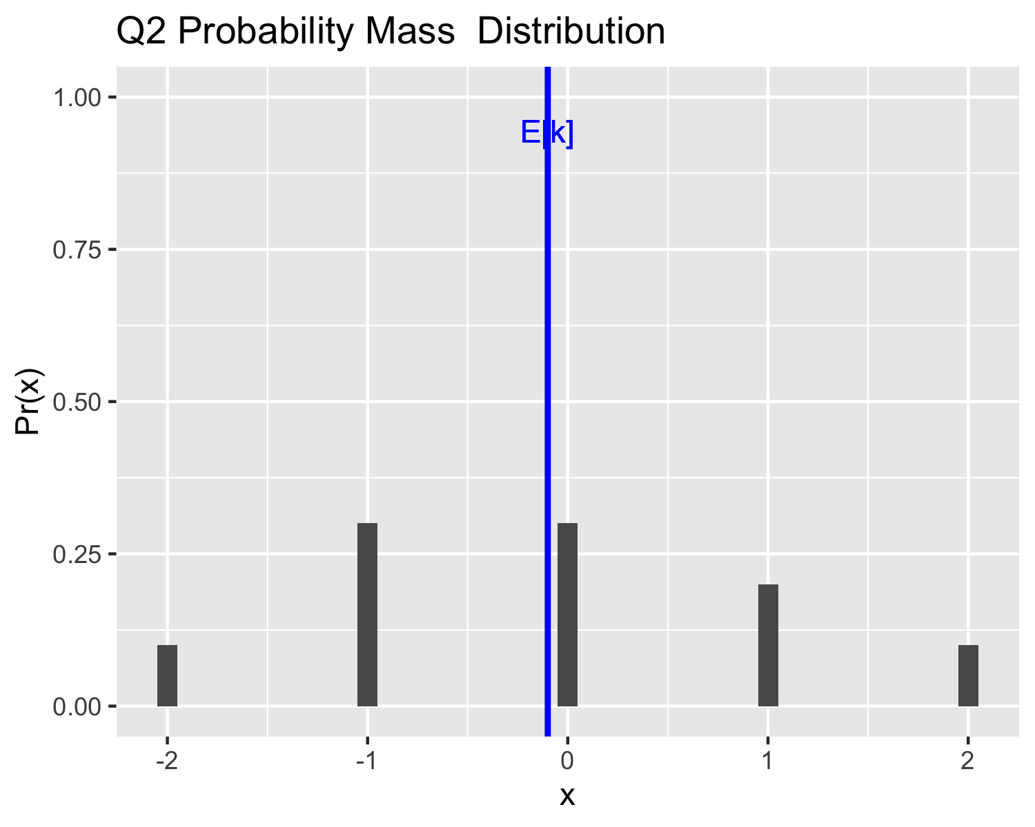

# Geometric Distribution

A Geometric distribution is used to describe the probability distribution if you do an experiment until you succeed, the experiment has two possible outcomes “success” or “failure”. The probability of “success” is , the probability of “failure” is . This gives the general definition of the distribution as:

with the expected outcome of,

and variance of

## Question 3

1. 20% of the Irish population watched Ireland beat France in the Rugby World Cup. A representative from TV3 marketing was sent to Grafton Street to ask passerbys their opinion of the match coverage. Let X denote the number of people need to be asked til the marketer successfully finds some who watched the game.

i Give the Geometric probability mass function for X.

### **ANSWER**

The probability of “success” is

the probability of “failure” is

This gives the general definition of the distribution as:

where k is the number of people asked by the marketer.

ii Find the probability that the marketer had to ask exactly 2 people.

### **ANSWER**

iii What is the E [X ] and V ar [X ] of the distribution.

**ANSWER**

The expected outcome of,

and variance of

Q3

| People | Pr_win |
| --- | --- |
| 1 | 0.2000000 |
| 2 | 0.1600000 |
| 3 | 0.1280000 |
| 4 | 0.1024000 |
| 5 | 0.0819200 |
| 6 | 0.0655360 |
| 7 | 0.0524288 |
| 8 | 0.0419430 |
| 9 | 0.0335544 |
| 10 | 0.0268435 |
| 11 | 0.0214748 |
| 12 | 0.0171799 |
| 13 | 0.0137439 |
| 14 | 0.0109951 |
| 15 | 0.0087961 |
| 16 | 0.0070369 |
| 17 | 0.0056295 |
| 18 | 0.0045036 |
| 19 | 0.0036029 |
| 20 | 0.0028823 |
| 21 | 0.0023058 |

